Installing the most up to date version of R for R Studio  
If you don’t run the latest version of R, then some packages will fail / not work.

1. Repeat the appstore installation, but search for R

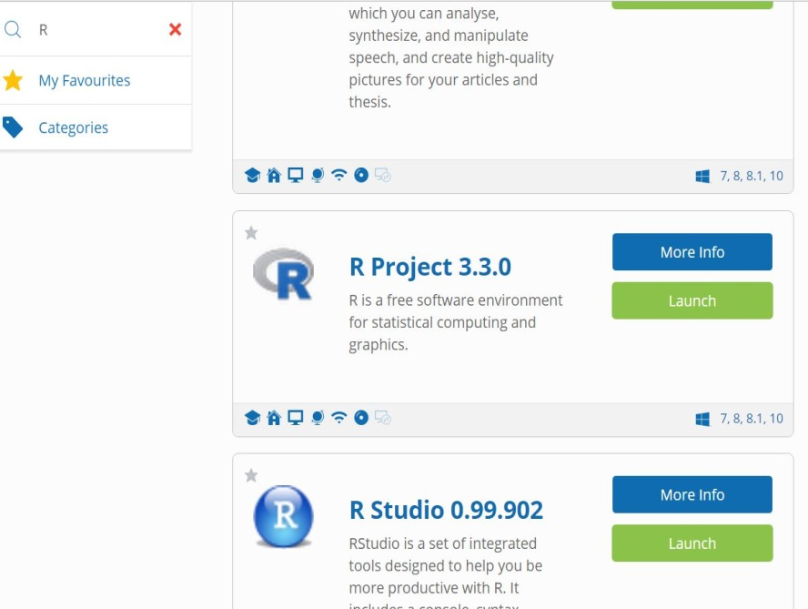

#

1. Close R Studio if it is open
2. In the Jukebox, launch R first *and then* R Studio second

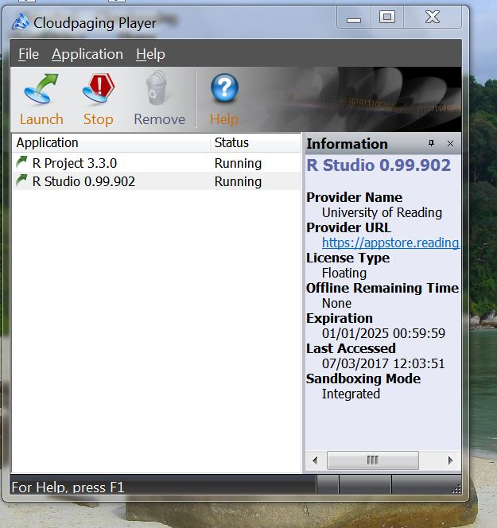

1. Check you have the latest version of R, by typing ‘version’ in the R console window

It should be 3.3.0 (or whatever is on the appstore at Reading)